Eventi
Use Case Specification

Submitted to:

Asst. Prof. Ma. Rowena C. Solamo
Faculty Member
Department of Computer Science
College of Engineering
University of the Philippines, Diliman

Submitted by:
Dimaano, Aaron Diego I.
Lopez, Matthew S.
Torres, Jacob Angelo V.

In partial fulfillment of academic requirements
for the course
CS 191 Software Engineering I
of the
1st Semester, AY 2015-2016
Unique Reference:
The documents are stored in https://github.com/Tom-2013-06417/CS191-192_Event_Sharing/tree/master/02-Requirements%20Engineering.
Link to this document: https://github.com/Tom-2013-06417/CS191-192_Event_Sharing/blob/master/02-Requirements%20Engineering/3.0%20-%20Create%20organization.pdf.

Document Purpose:
The purpose of this document is to exhaust the step-by-step process of the Use Cases in every scenario possible.

Target Audience:
To our project client and adviser, our fellow 191 classmates, and our future selves when they need to refer back to this document.

Revision Control:

Revision Date | Person Responsible | Version  Number | Modification
09/18/15 | Dimaano, Diego  Lopez, Matthew  Torres, Jacob | 1.0 | Initial Document

Use-Case Name: Create organization

Description: This is a feature concerning the Registered User. If an organization page does not exist, a user may create one and use it as the medium to post events under the organization name. This serves as the centralization of events per org.

Preconditions: The Registered User has an account and is logged in.

Flow of Events:

Scenario Name | Description
Scenario 1 (Basic Flow)  Registered User creates an organization | - Registered User goes to the create Organization page  2. System prompts Registered User to provide the Organization's credentials  3. Registered User provides the system with the Organization's credentials  4. System accepts the credentials provided by the Registered User for the organization  5. The Organization is created under the Registered User
Scenario 2  Registered User provides invalid credentials for creating the organization | - System points out the invalidity in the provided credentials  - System prompts RU to re-input the Organization's credentials.

Activity Diagram of the Flow of Events:

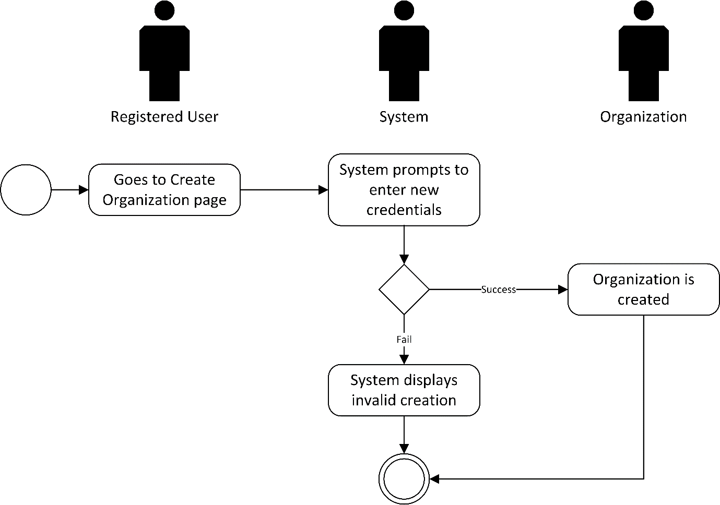

Post-conditions: Successful: The Registered User successfully created an organization.
Failed: The organization wasn’t created.
The website did not load.

Special Requirements:
Upload the organization image.

